Medicines Optimisation Newsletter
[January 2024] (Issue No. 54)

- Antibiotic Course Length
- Interaction of tramadol and warfarin
- Pregabalin and risk in pregnancy / Gabapentinoid prescribing
- FreeStyle Libre 3
- Kent and Medway List of New Approved Guidelines
- MHRA Drug Safety Update
- Update to the NPSA on GLP-1 RAs
- Shortages
Kent and Medway ICB Updates
Safety and Improvement

Antibiotic Course Length

Reducing course length of antimicrobial prescribing is one of the 16 National Medicines Optimisation Opportunities for 2023/24.
Since the project was initiated at the end of September within Kent and Medway, we have seen a significant increase in the proportion of amoxicillin prescriptions that are prescribed as 5-day courses moving from 28.5% in September 2023 up to 46.3% in November 2023. A fantastic improvement! The aim is to reach 75% by March 2024.
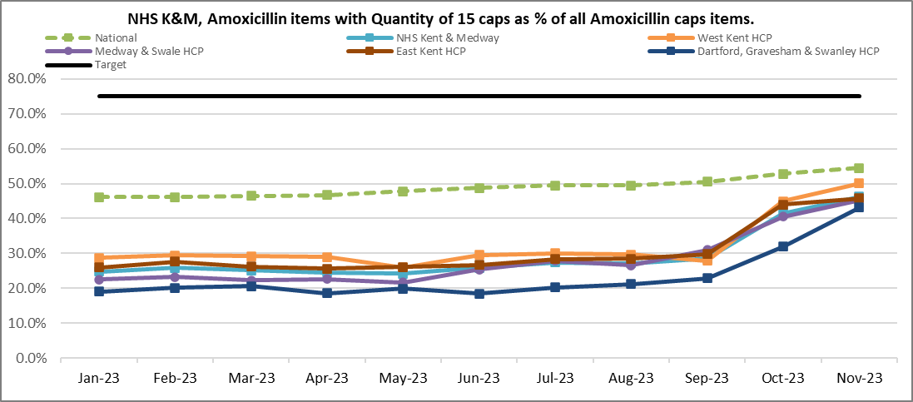
Amoxicillin is the most prescribed antibiotic in primary care and its use has been linked to E-Coli resistance and C. difficile diarrhoea. Ensuring that the shortest appropriate duration is prescribed is useful from both a societal and individual point of view, aiding the national ambition to reduce antimicrobial use and the development of resistance.
Recent audit work in practice has revealed that some COPD rescue packs are being issued with 7 days’ supply and on repeat prescriptions. Please note that:

- COPD rescue packs should not be on repeat prescription and should remain as acute items.
- All antibiotics and oral corticosteroids within COPD rescue packs should have a 5-day course length.

Expanding the project
There is a further ambition to increase the proportion of courses prescribed as 5 days for doxycycline and flucloxacillin. Please see embedded documents for further details. ScriptSwitch messages are being added to support these ambitions.

Interaction of tramadol and warfarin

The Pharmaceutical Journal (PJ) has reported that NHS England has been told it must take action to raise awareness about the potentially fatal interaction between tramadol and warfarin, following the death of a patient (here). This interaction is noted in the SmPC for Tramadol but not in the BNF. The SmPC states: “Caution should be exercised during concomitant treatment with tramadol and coumarin derivatives (e.g., warfarin) due to reports of increased INR with major bleeding and ecchymoses in some patients.” The PJ article states that a spokesperson for the BNF said the interaction would be included in the BNF from January 2024 in response to the assistant coroner’s report.

Pregabalin and risk in pregnancy / Gabapentinoid prescribing

National prescribing data shows NHS Kent and Medway has continuously prescribed more gabapentinoids than the national average throughout the past year.
We have conducted audits in our top gabapentinoid prescribing practices in Medway and Swale and found:
- Majority of the prescribing was initiated in primary care with the main indication being ‘back pain’.
- Some physiotherapists were advising GPs to prescribe a gabapentinoid for an indication other than neuropathic pain – this is not recommended.
- Only 34% of patients reported a clear record of patient benefit six weeks during the start of treatment that was documented.
- Only 13% of women within childbearing age were provided with counselling of using Pregabalin and risks in pregnancy.

Below are the recommendations for good prescribing practice with gabapentinoids based on the findings of the audit:
- Where pain is present, gabapentinoids should only be prescribed for NEUROPATHIC pain.
- The monitoring and reviewing responsibilities should be considered and documented at initiation.
- Pregabalin users who are of childbearing age should receive counselling from their clinician/doctor at every encounter, consultation, and prescription collection opportunity.
- Non-prescribers in community and secondary care are advised not to recommend the prescribing or use of medications.
- We encourage GPs to use the Ardens Controlled drug template tool which provides prompts and covers MHRA alerts e.g., risks with pregnancy and pregabalin.
- The efficacy of gabapentinoids should be reviewed within 6 weeks of treatment.
The development of local guidelines on gabapentinoids is the next phase in Kent and Medway, following audits across further Health and Care Partnerships.

Formulary and Guidance

FreeStyle Libre 3

FreeStyle Libre 3 has recently become available in the drug tariff and available for prescribing on FP-10 prescriptions. Practices are asked not to prescribe this item. The integration of FreeStyle Libre 3 aligns with the NICE technology appraisal on hybrid closed loop technology. This is part of a comprehensive 5-year rollout plan currently under development in collaboration with specialists and guidance from NHS England. Further details regarding its prescribing position will be disseminated post-approval through ICB governance processes and pathway development.

Action for practices = It is not recommended for practices to prescribe FreeStyle Libre 3

Kent and Medway List of New Approved Guidelines

National Updates

MHRA Drug Safety Update

The latest MHRA Drug Safety Updates can be accessed at Drug Safety Update - GOV.UK (www.gov.uk) . This includes links to alerts, recalls and safety information and to the monthly Drug Safety Update PDF newsletter.
The December 2023 Drug Safety Update includes:
Aripiprazole (Abilify and generic brands): risk of pathological gambling - GOV.UK (www.gov.uk)
Healthcare professionals prescribing aripiprazole are reminded to be alert to the risk of addictive gambling and other impulse control disorders. Healthcare professionals should advise patients, their families and friends to be alert to these risks.
Vitamin B12 (hydroxocobalamin, cyanocobalamin): advise patients with known cobalt allergy to be vigilant for sensitivity reactions - GOV.UK (www.gov.uk)
The medicines used to treat vitamin B12 deficiency (hydroxocobalamin, cyanocobalamin) contain cobalt. There are case reports in the literature describing cobalt sensitivity-type reactions in patients being treated for vitamin B12 deficiency.
The MHRA advise that healthcare professionals prescribing vitamin B12 products to patients with known cobalt allergy should advise patients to be vigilant for signs and symptoms of cobalt sensitivity and treat as appropriate.

MHRA Advice for healthcare professionals:

- cobalt sensitivity reactions typically present with cutaneous symptoms of chronic or subacute allergic contact dermatitis. Infrequently, cobalt allergy may trigger an erythema multiforme-like reaction. Symptom onset may be immediate or delayed up to 72 hours post-administration
- cobalt allergy is estimated to affect 1 to 3% of the general population 1^{[footnote 1]}.
- if cobalt sensitivity-type reactions occur, assess the individual benefits and risks of continuing treatment and, if necessary to continue, advise patients on appropriate management of symptoms
- report suspected adverse drug reactions to the Yellow Card scheme

Letters and medicine recalls sent to healthcare professionals in November 2023 - GOV.UK (www.gov.uk)

Please follow the link in the titles above for more information and resources.

NATIONAL CAS ALERTS (National Patient Safety Alerts and CMO Messages):
The MHRA Central Alerting System alerts can be accessed at https://www.cas.mhra.gov.uk/Home.aspx
Influenza Season 2023/24: Use of antiviral medicines

Update to the NPSA on GLP-1 RAs
There has been an update to the National Patient Safety Alert (NPSA) on glucagon-like peptide-1 receptor agonists (GLP-1 RAs), issued on the 3rd of January 2024. This NPSA alert supersedes the previous NPSA alert released on the 18th of July 2023 (NatPSA/2023/008/DHSC). Actions are to be completed by the 28th of March 2024.

The key updates and summary of the NPSA are in the document below:

The visual representation below of the NPSA provides clarity on some points within the NPSA, other points to consider as well as further information on Rybelsus. Comments have been sought on this document from specialists within Kent and Medway before sharing.

We would like to emphasise that we are aware of prescribing of GLP-1 RAs for off-label indications. This is not recommended by the NPSA and further reiterated by the position statement on our formulary websites. GLP-1 RA stock must be conserved for those patients living with type 2 diabetes mellitus. Any requests from
other healthcare providers for off-label indications should be highlighted to the medicines optimisation team.

The patient information leaflet for patients taking GLP-1 RAs for type 2 diabetes will be updated based on the updated NPSA on the Kent and Medway website here in due course. There is also further information on the Diabetes UK website here aimed to support patients at this time.
Please read the key documents such as the NPSA, NICE guidelines on managing type 2 diabetes, and ABCD and PCDS guidance. Please ensure that all staff, especially those involved in the management of and prescribing for diabetes are made aware of these changes.
The Specialist Pharmacy Service (SPS) should also be used for up to date information on supply, which can be found here Prescribing available GLP-1 receptor agonists – SPS - Specialist Pharmacy Service – The first stop for professional medicines advice

Shortages
Shortage of epilepsy medication

Medicine | Anticipated re-supply date
Tegretol Prolonged Release 200mg tablets (Novartis Pharmaceuticals UK Ltd) | 17 January 2024
Tegretol Prolonged Release 400mg tablets (Novartis Pharmaceuticals UK Ltd) | 2 February 2024

A Medicines Supply Notification (MSN) was issued on 10th January 2024: MSN_2024_004_Carbamazepine_Tegretol_200mg_and_400mg_PR_tablets.pdf (cpsc.org.uk)

- Tegretol 400mg PR tablets remain available but cannot support an uplift in demand and will be out of stock from w/e 12th January until w/c 29th January 2024
- Tegretol immediate release (IR) tablets remain available and can support increased demand
- Curatil 200mg PR tablets remain available but can only support increased demand in secondary care
Prescribers should not initiate new patients on Tegretol® PR tablets until the shortages have resolved.

For the shortage of Tegretol 400mg PR tablets:
- Prescribers should consider prescribing Tegretol 200mg prolonged release tablets to make up the required dose
Shortages Summary

Please find the medicines shortages update (up until 12th January 2024) attached. Practices are encouraged to register for access to the SPS website https://www.sps.nhs.uk/ and access the full medicines supply tool directly in real time.

